*SMART HOME*

Submitted by

X.Jibisha

961819106026

Electronics and Communication Engineering

Ponjesly College of Engineering

***GLOWING LIGHT USING PIR SENSOR***

**CODE:**

// C++ code

//Blink-makes a single LED blink on and off

void setup()

{

Serial.begin(9600);

pinMode(4,INPUT);

pinMode(13,OUTPUT);

}

void loop()

{

int p=digitalRead(4);

Serial.println(p);

if(p)

digitalWrite(13,HIGH);

else

digitalWrite(13,LOW);

delay(1000);

}

**TINKERCAD LINK:**

<https://www.tinkercad.com/things/cSUVqfqxQiW-glorious-leelo/editel?sharecode=bvNCefCPz0BSjw2trDRUJwRCi9qsh9rsL443ESpFXY0>

**FIGURE:**

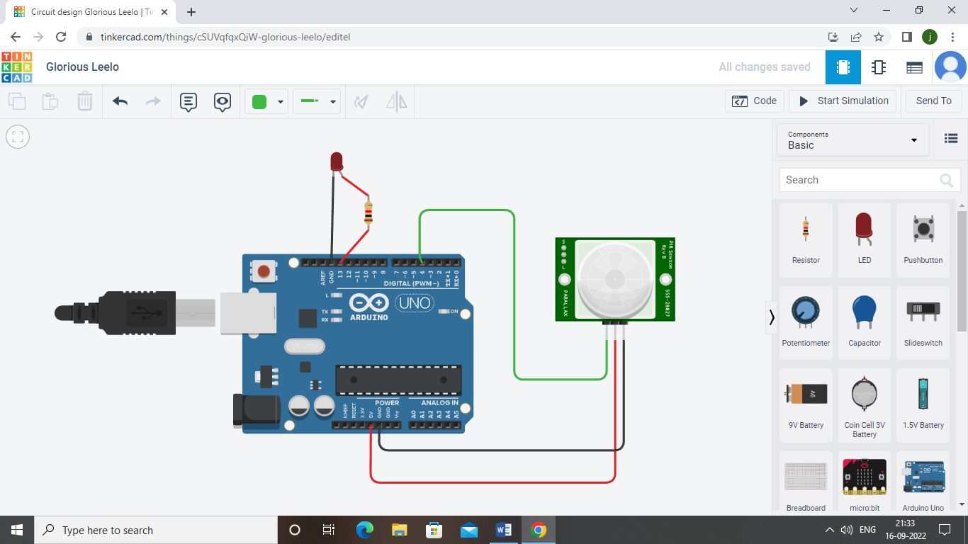

Two components are connected to the aurdino PIR sensor is used to detect the motion of the sensor and when the motion is detected the LED starts to glow.